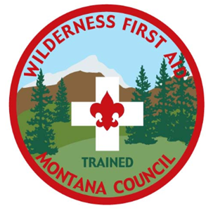
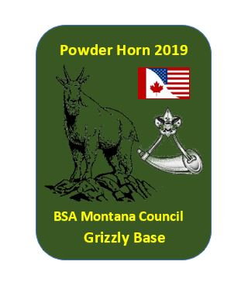
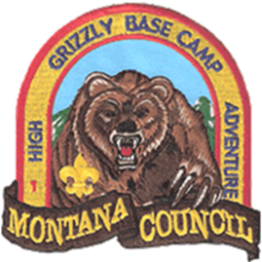

Powder Horn High Adventure Management Resource Course/ BSA16-hr Wilderness First Aid Course.
Aug 15, 16, 17, 18 with Checking late afternoon Aug 14, 2019
Location: Grizzly Base
Co Course Directors: Tony Higuera and Jim Atkinson

Mark your calendars! Only accepting 25 participants, Youth and Adult. So don’t wait to register. For adult interested, we are targeting those adults who are Direct Contact Leaders who are serious about improving their unit program. Everyone needs to be in fair shape to do the activities. This is a hands on course.
Why Powder Horn? Many Scouting leaders face the dilemma of having a strong desire to provide challenging and fun outdoor programs to meet the needs of their older youth members, but lack the knowledge and/or resources to do so. Powder Horn responds to the quandary with an exciting new training opportunity that exposes Venturing, Boy Scout leaders, and Cub Scout leaders, Venturing Program Youth and Boy Scout Program Youth to a wide range of outdoor/high adventure activities. More importantly, Powder Horn provides its participants with valuable resource and contacts to assist them in delivering the promise of Scouting’s high adventure to youth. At least 10 High Adventure subject will be presented during the course. In 2019 we will be offering WFA as part of your PH training. A core subject in the PH syllabi and highly recommended certification in the high adventure programs. You will be able to either get your initial WFA cert or Re certification if you have taken it in the past.
Who May Attend a Powder Horn Course and Wilderness First Aid?
Powder Horn is open to any youth who is at least 14 years of age (or 13 and has completed
eighth grade, if part of a Venturing crew) or any adult registered in the BSA. Participant
guidelines include:
- Youth must have completed the unit’s version of leadership training (Introduction to
Leadership Skills for Troops, Ships, or Crews). Previous attendance at National Youth
Leadership Training (NYLT)
- Adults must be trained for their position.
- All Adult participants must complete BSA Youth Protection. ALL participants (Adult and Youth) must complete Hazardous Weather Training, Safety Afloat, Safe Swim Defense, and Trek Safely prior to the course.
- Meet the physical requirements contained in the Annual Health and Medical Record
physical in a backcountry environment. Forms A, B, And C. Bring medical forms with you to course

Recognition:
Upon successful completion of the Powder Horn course and Wilderness First Aid participants will be awarded a certificate of completion for both courses and the Powder Horn Device and WFA Trained Patch. The PH devise is worn hanging from the left pocket of the uniform.
Course cost: $350.00, deposit of $100 due with registration form, balance due NLT June 15, 2019

Some of the many activities you may expect this coming year:

Wilderness First Aid certification or re certification
White Water Rafting on the Flathead River
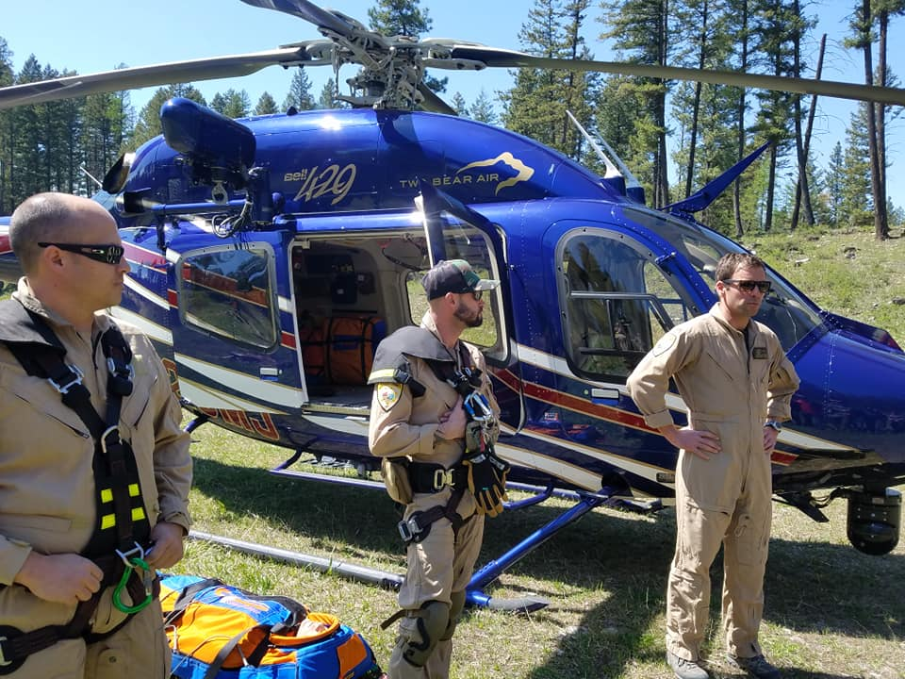
Sailing in the Flathead Lake
Two Bear Air Rescue Demonstration
Wilderness Survival/Map Reading
Risk Management training
Daily High Adventure Team Challenges

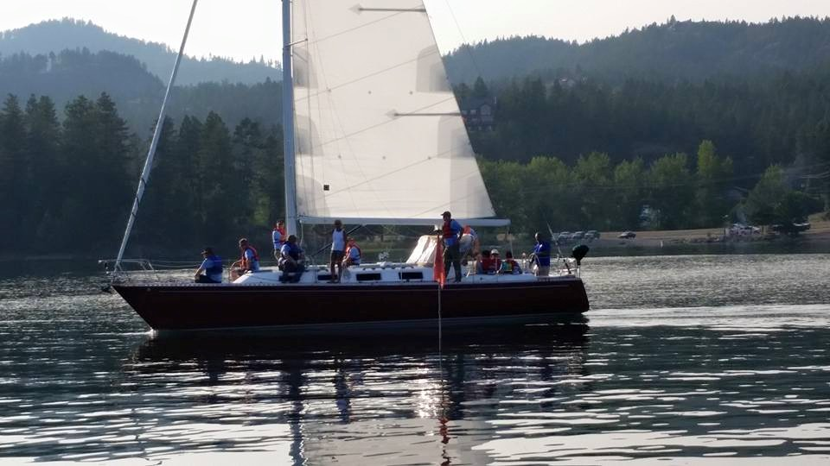

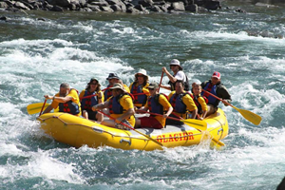

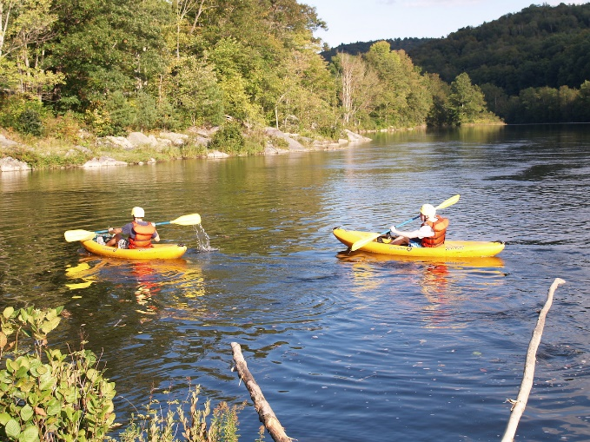

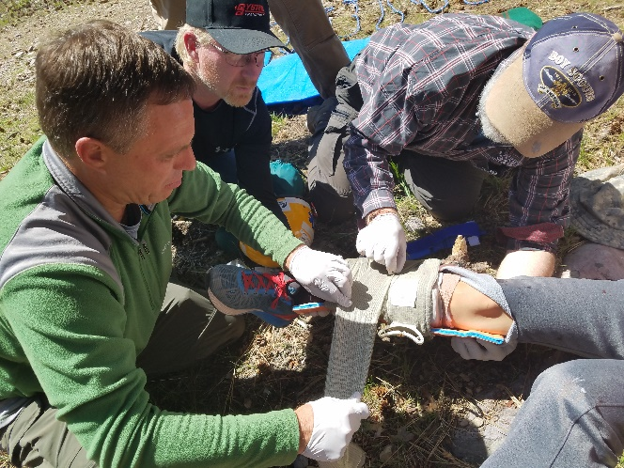

Boy Scouts of America Montana Council
Powder Horn 2019
Grizzly Base
Registration Form (Please print)

Course cost $350.00, Deposit of $100.00 with this Registration form, balance due to Council no later than June 15, 2019. Make checks payable to BSA Montana Council, Indicate Powder Horn 2019 on check and front of envelope. Mail registration form with deposit to BSA Montana Council, 820 17th Avenue South, Great Falls, Montana 59405-5939

Registration on the course is not official until the council receive deposit of $100.00 and is not final until council gets course cost balance by June 15, 2019.

Name: ______________________________________BSA membership Number: _____________________

Email: _______________________________________________ if youth is registering for the course please

add parent email address here: ________________________________________

Address: ___________________________________________________________

Primary Phone number: _______________________ Secondary Phone number: _______________________

Adult: Primary BSA position__________________________ Unit number: _________________
Gender: _______________

**** Adults: I understand that I must have current training on primary adult scout position and have completed BSA Youth Protection and Hazardous Weather, Safety Afloat and Safe Swim Defense, and Trek Safely prior to the course. Must provide proof at beginning of course. Sign here: _________________________________

Youth: Age___________, Rank____________________, Unit number___________________
Gender: _______________
NYLT Graduation date: __________________

**** Youth: I understand that I must have current training on Hazardous Weather, Safety Afloat, Safe Swim Defense, and Trek Safely prior to the course. Must provide proof at beginning of course.
Sign here: ___________________________________

Adult and Youth: Food allergies: ____________________
Dietary food restrictions____________________________

Any other limitations we should know about _____________________________________

Wilderness First Aid (WFA): New Certification_____ or Re certifying________

T-shirt Size: Adult Sizes only
Small_______
Medium_________
Large___________
X large__________
2XL__________

What you need to bring with you

- Full BSA Field uniform
- Enough Activity T-shirts to last the course duration. One Course T-shirt will be provided on the first day. Enough Shorts and underclothing to last the entire course
- Tent and Ground cloth
- Sleeping bag, sleeping cot if you desire
- Swim shorts, Cloth that can get wet
- River or water shoes
- Rain gear
- Cool weather jacket if weather calls for it
- Comfortable shoes
- Camping chair
- Towel and toiletry items
- Flash light
- Personal snacks if desire
- Appropriate head gear
- Sun screen
- Mosquito repellent
- Personal prescription medication in original bottle if applicable
- Water bottle
- Day pack
- Personal First Aid kit

